HD 70642

HD 70642 is a 1.0 M☉, G5 star1. Based on 21 RV UCLES measurements obtained between 1998 and 2003, a study performed in 2003 (hereafter C03)1 reported a GP signal with a period of 2231 ± 400 days, a minimum mass of 2 MJup and an eccentricity of 0.1 ± 0.06. The CH survey reported a GP signal with properties close to those reported in the C03 study.

In the present study, 28 UCLES data measurements obtained between 1998 and 2005 and 40 RV HARPS measurements obtained between 2003 and 2019 were considered. DPASS and MCMC (1000 walkers and 300000 iterations) were used to fit the data. The properties of HD 70642b are close to those reported in the CH survey.

The fits are shown in Fig 1, and the corner plot in Fig 2, and the results summarized in Table 1.

Conclusion: The properties used in the CH survey for HD 70642b are confirmed.

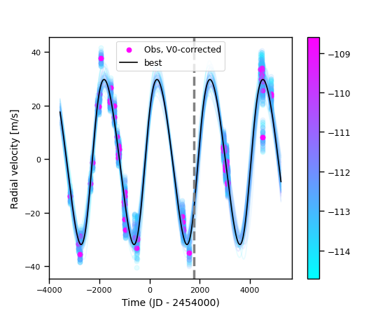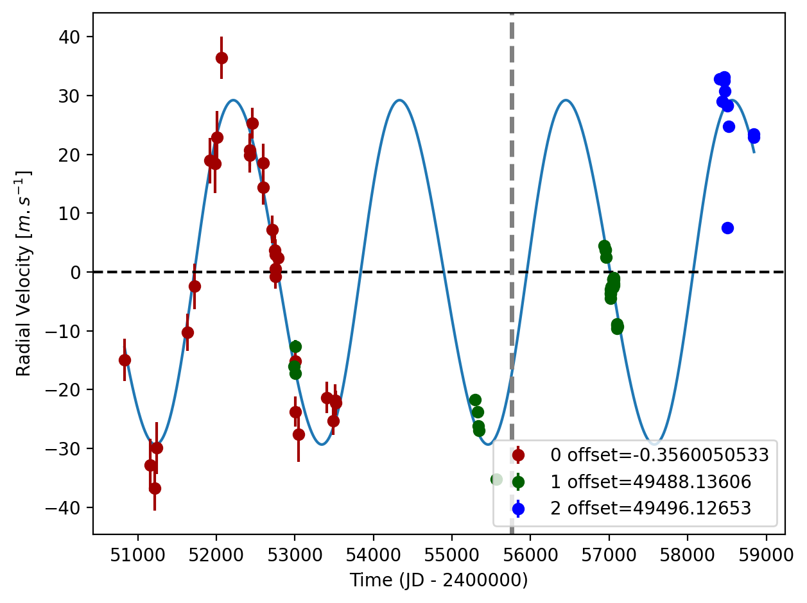

Figure 1: Left: fit of the HD 70642 RV with DPASS. Red - UCLES, green - H03, blue - H15. The blue curve shows the best fit. Right: fit of the HD 70642 RV using MCMC. The black curve shows the best fit. The colorbar corresponds to the log-likelihood of the fits. The gray dotted line indicates the end of the CH survey.

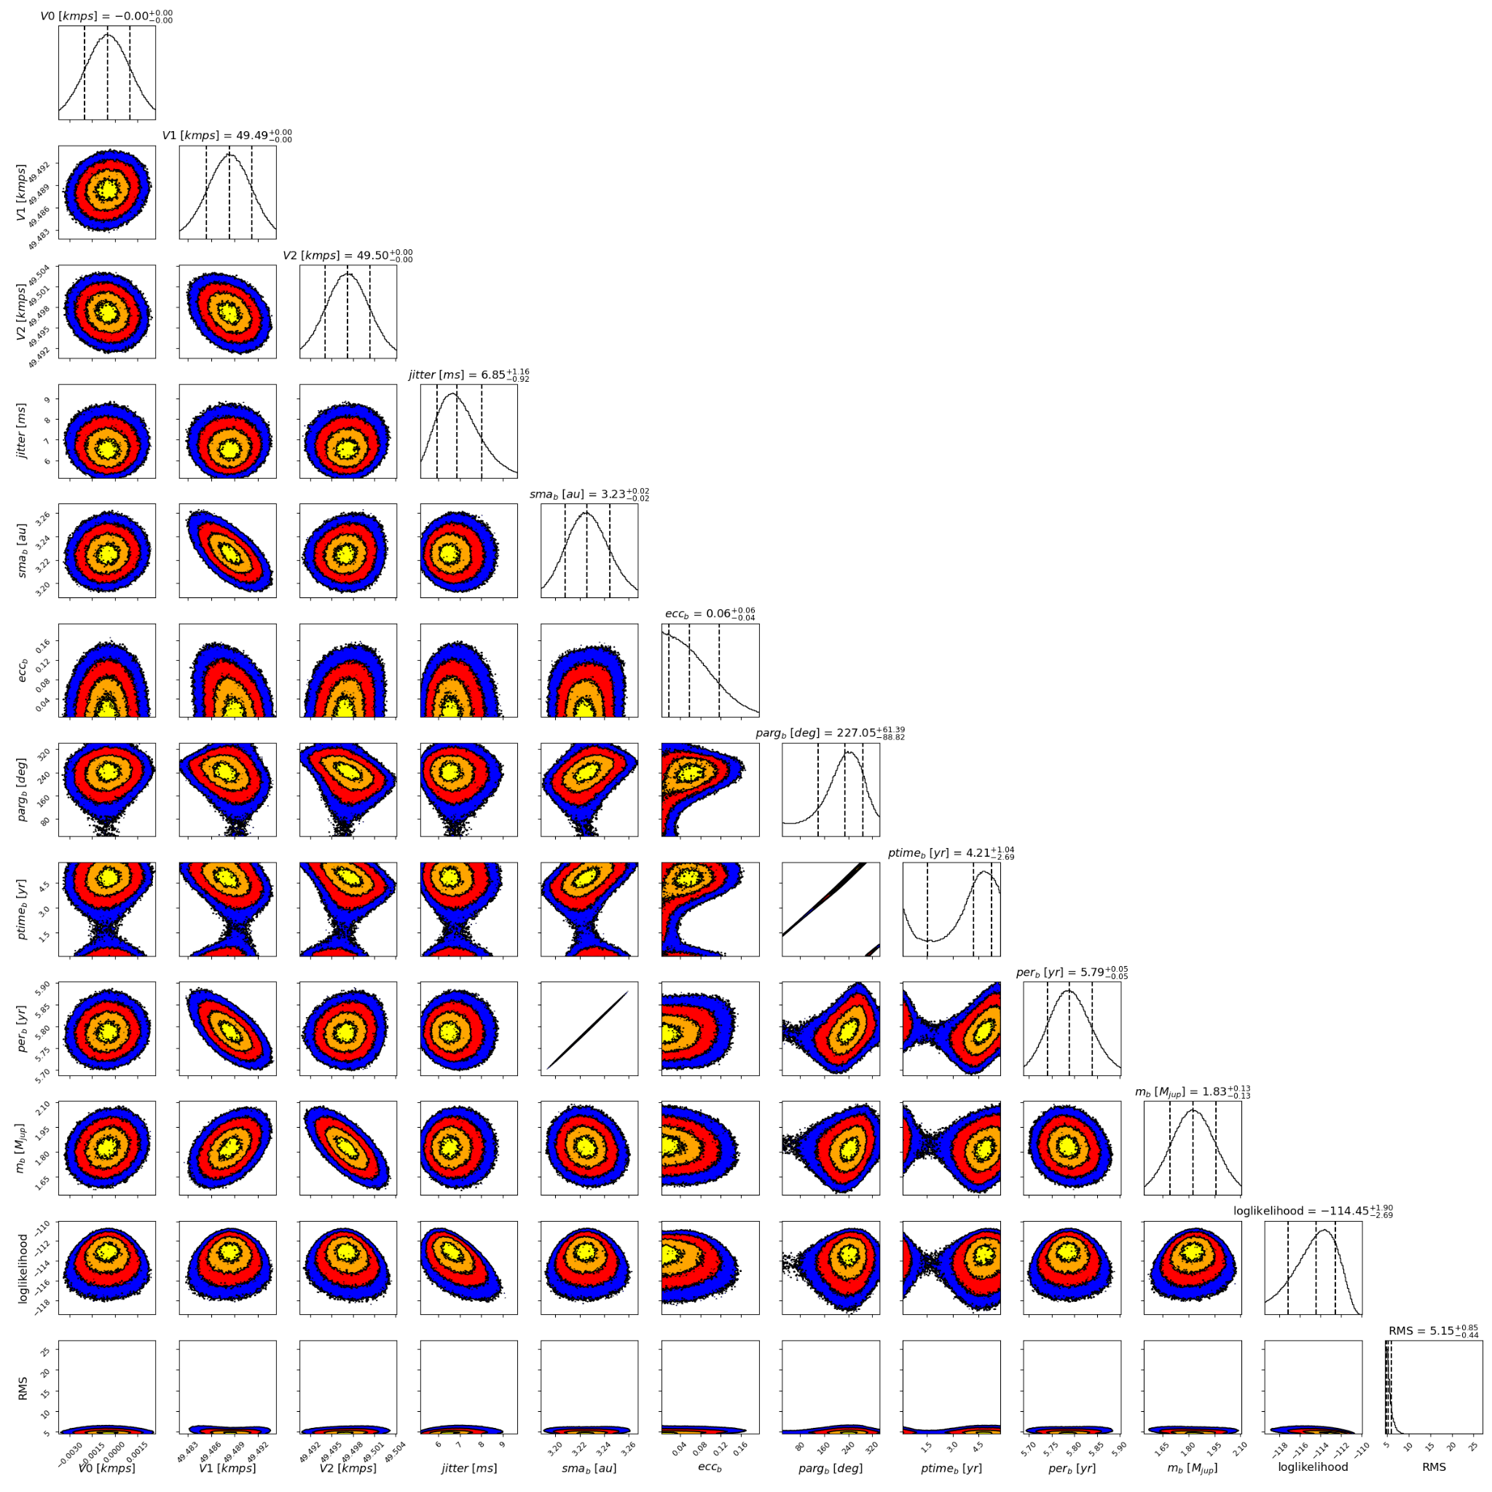

Figure 2: Corner plot of posteriors for the one-planet model MCMC fit of HD 70642 RV data.

| Parameter | Priors | | Posteriors | | CH survey |
| --- | --- | --- | --- | --- | --- |
|  | DPASS | MCMC | DPASS | MCMC |  |
| *a* (au) | [3,80] | [1,5] | 3.2 | 3.23 ± 0.02 | 3.2 |
| Msin(i) (MJup) | [0,100] | [0.5,10] | 1.9 | 1.8 ± 0.1 | 1.9 |
| Eccentricity | [0,0.5] | [0,0.9] | 0.05 | < 0.12 | 0.03 |
| Instrumentals offsets (km/s) | [-100,100] | UCLES: [-1,1]  H03: [48,50]  H15: [48,50] | UCLES: -0.0003  H03: 49.488  H15: 49.496 | UCLES:  H03: 49.488 ± 0.003  H15: 49.497 ± 0.003 |  |
| Stellar jitter (m/s) | [0,40] | [0,20] | 5.8 |  |  |
| Argument of periastron (°) | [0,360] | [0,360] | 268 |  |  |
| Phase | [0,1] | [0,1] | 0.43 | 0.26 – 0.90 |  |

Table 1: HD 70642. Summary of priors and posteriors obtained with DPASS and MCMC, compared to the properties reported by the CH Survey.

References

1. Carter, B. et al. A Planet in a Circular Orbit with a 6 Year Period. *Astrophys. J.* 593, L43-L46 (2003).